|  |
| --- |
| **Team ID :** LTVIP2025TMID57320 |
| **Project Name :** OrderOnTheGo: Your On-Demand Food Ordering Solution |

**Frontend development**

**1. Setup React Application:**

• Create a React app in the client folder.   
• Install required libraries   
• Create required pages and components and add routes.

**2.Design UI components:**

• Create Components.   
• Implement layout and styling.   
• Add navigation.

**3.Implement frontend logic:**

• Integration with API endpoints.   
• Implement data binding.

Reference Article Link:

<https://www.w3schools.com/react/react_getstarted.asp>

Reference Image:

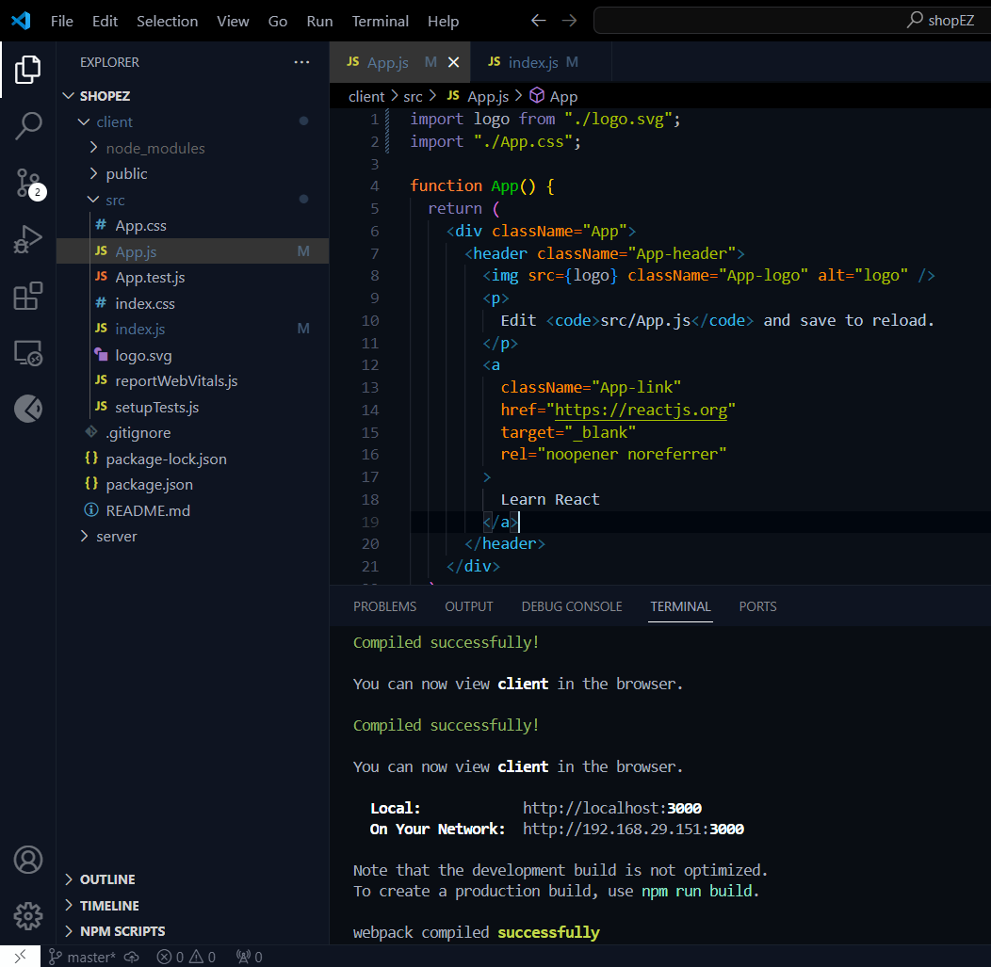

**Code Explanation:**

Server setup:

Let us import all the required tools/libraries and connect the database.

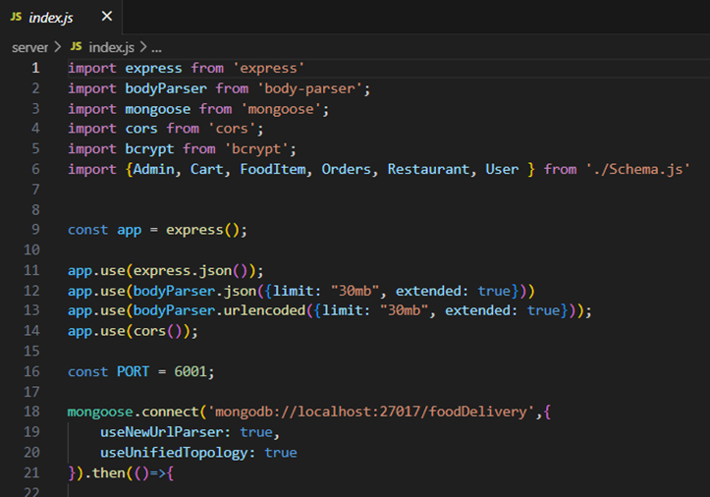

**User Authentication:**

**·       Backend**

Now, here we define the functions to handle http requests from the client for authentication.

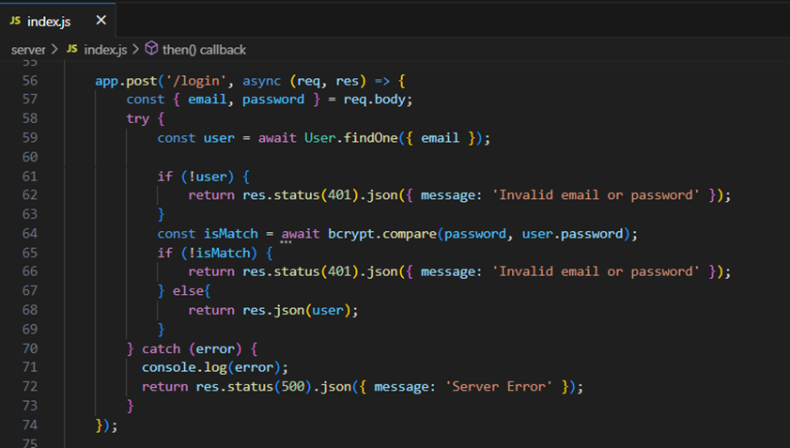

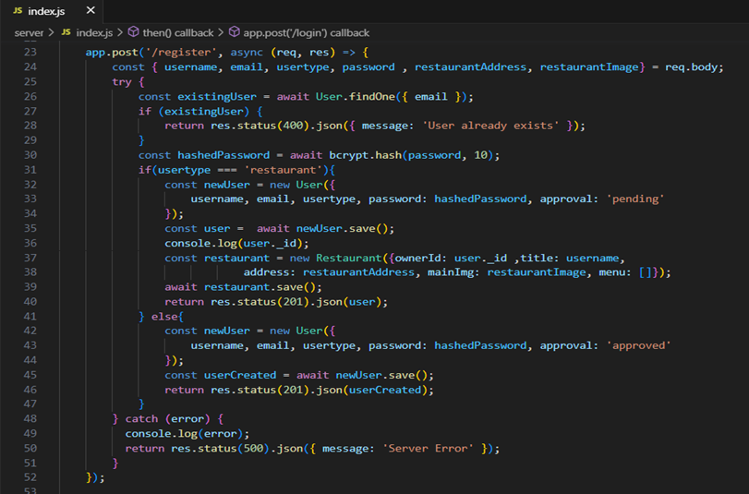

·       **Frontend**

Login:

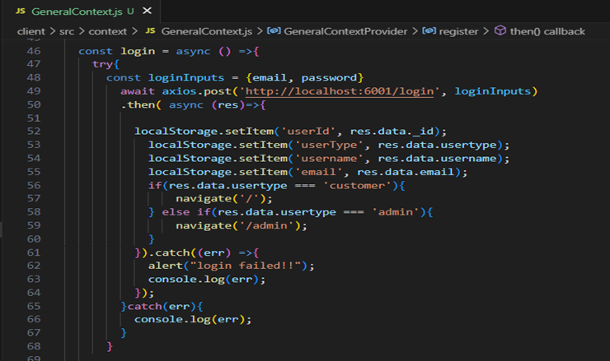

Logout:

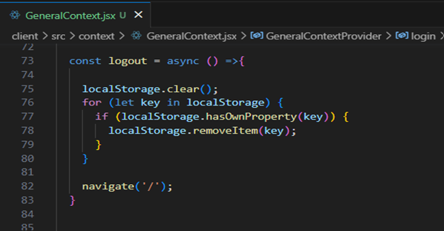

Register:

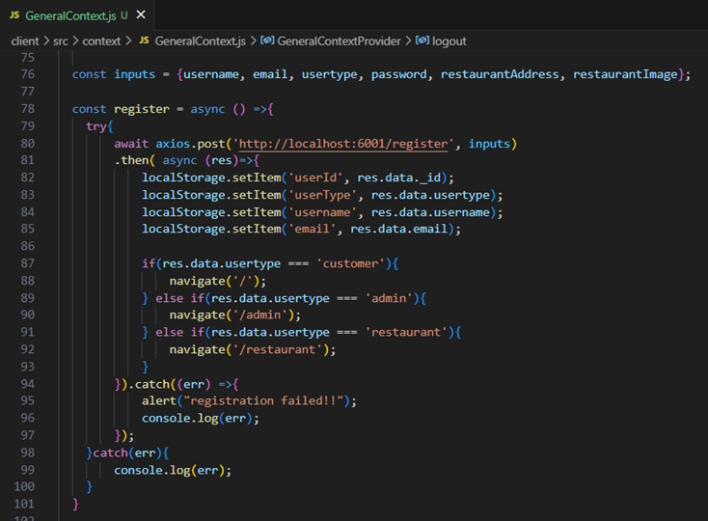

**All Products (User):**

·       Frontend

In the home page, we’ll fetch all the products available in the platform along with the filters.

            Fetching food items:

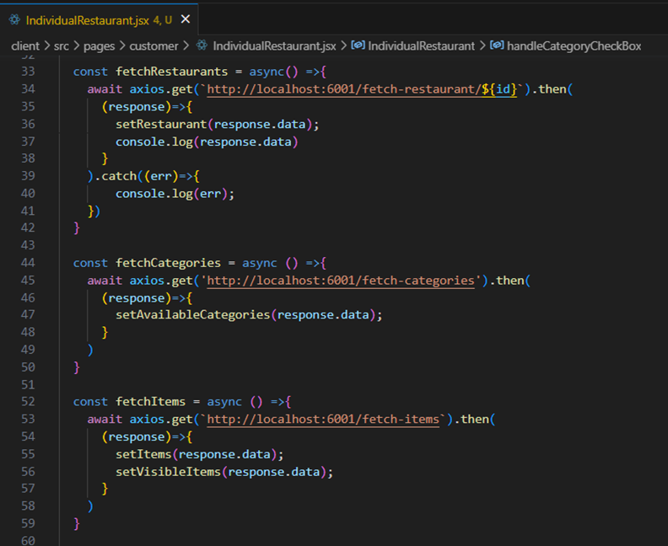

Filtering products:

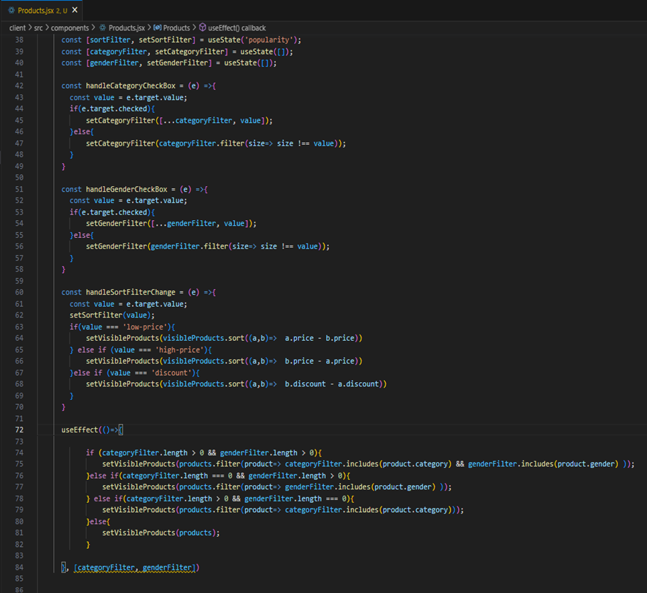

**·       Backend**

     In the backend, we fetch all the products and then filter them on the client side.

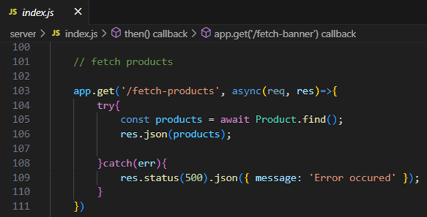

**Add product to cart:**

·       **Frontend**

Here, we can add the product to the cart and later can buy them.

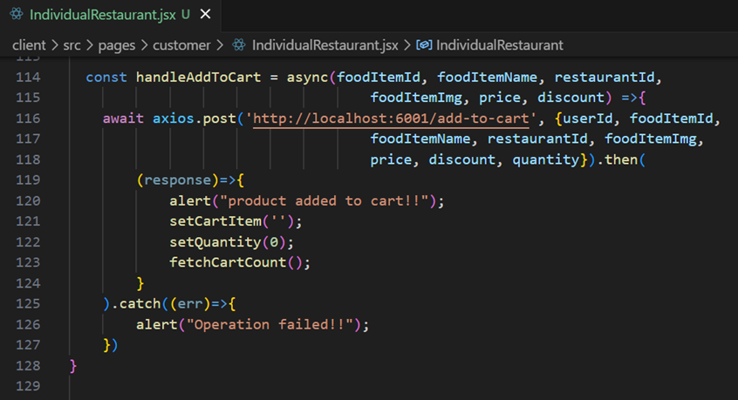

**·       Backend**

Add product to cart:

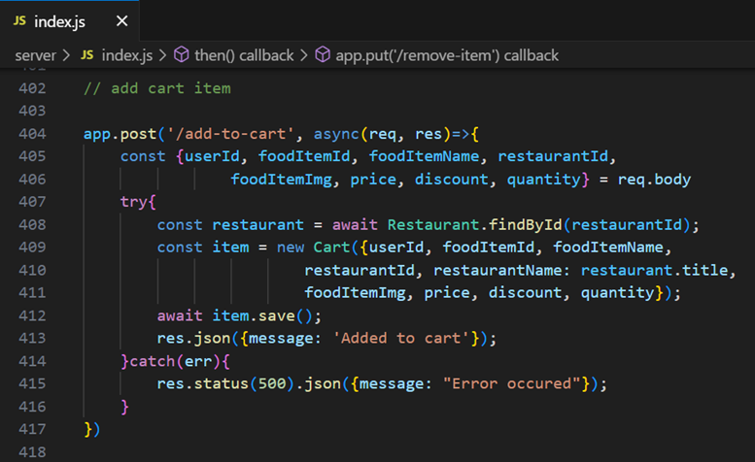

**Order products:**

Now, from the cart, let’s place the order

·       Frontend

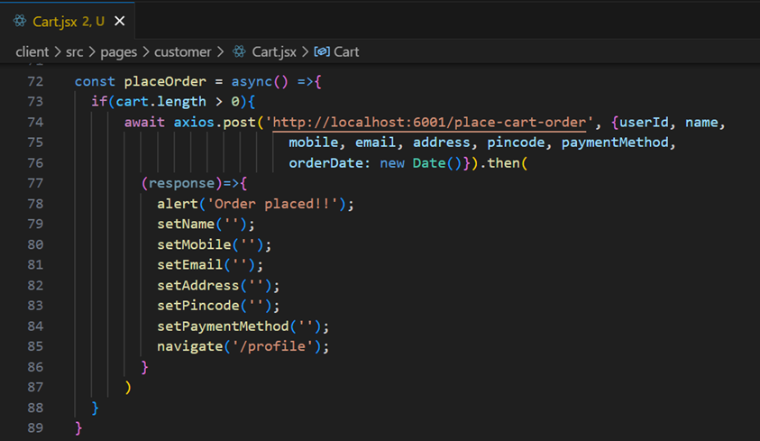

·       **Backend**

   In the backend, on receiving the request from the client, we then place the order for the products in the cart with the specific user Id.

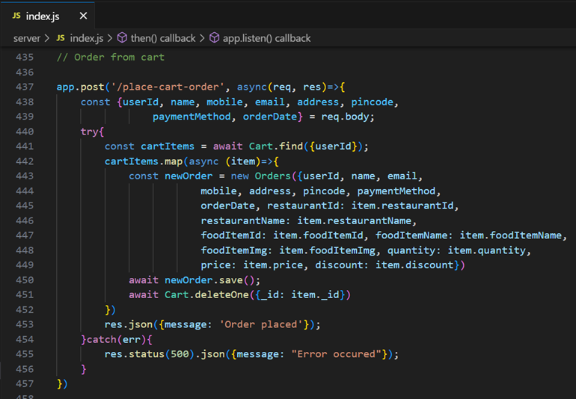

**Add new product:**

Here, in the admin dashboard, we will add a new product.

·       Frontend:

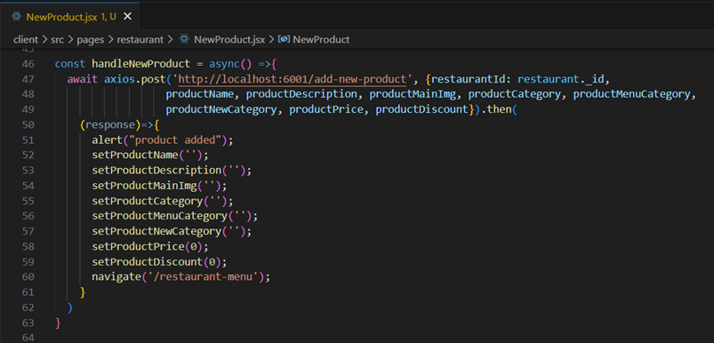

      ·       **Backend:**

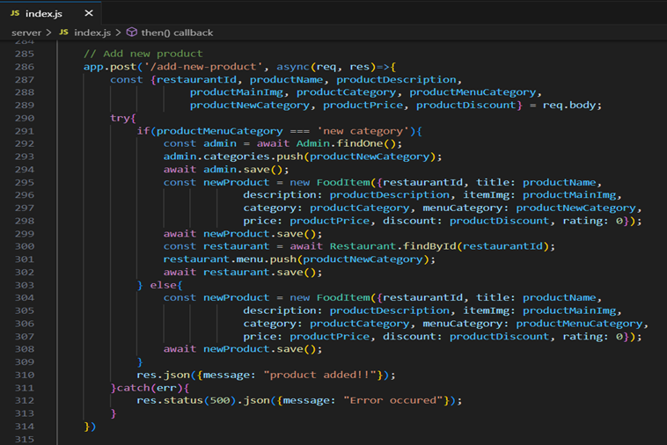

Along with this, implement additional features to view all orders, products, etc., in the admin dashboard.